|  |  |
| --- | --- |
| Understanding Maven: The Cornerstone of Java Project Management | Microsoft Word logo |

Maven is a powerful build automation tool that simplifies the management of Java projects. It provides a standardized way to build, package, and deploy applications, making it an indispensable tool for software development teams. This document will explore Maven's role, the structure of Maven projects, and how to create and manage Maven projects effectively.

Maven's Role in Software Development

Maven is a crucial component in the software development lifecycle. It serves as a project management and comprehension tool, helping teams manage the complexity of modern Java projects. Maven's primary responsibilities include dependency management, project building, testing, and deployment. By standardizing these processes, Maven ensures consistency, reproducibility, and streamlined collaboration across development teams.

At its core, Maven enforces a convention-over-configuration approach, which means that it provides sensible defaults for common project structures and build processes. This allows developers to focus on writing code rather than configuring complex build systems, ultimately improving productivity and project quality.

Maven Project Structure

Maven projects follow a standardized directory structure, which helps maintain consistency and makes it easier for developers to navigate and understand the codebase. The main components of a Maven project include:

* src/main/java: Contains the main source code
* src/test/java: Contains the test code
* pom.xml: The Project Object Model (POM), which is the heart of a Maven project and defines the project's configuration, dependencies, and build settings
* target: The directory where Maven stores the compiled code, generated resources, and the final packaged artifact

This organized structure promotes best practices, facilitates collaboration, and simplifies the overall management of the project lifecycle.

With this document saved in OneDrive, you can share it with others. They don’t even need Word to open it.

Maven Project Structure:

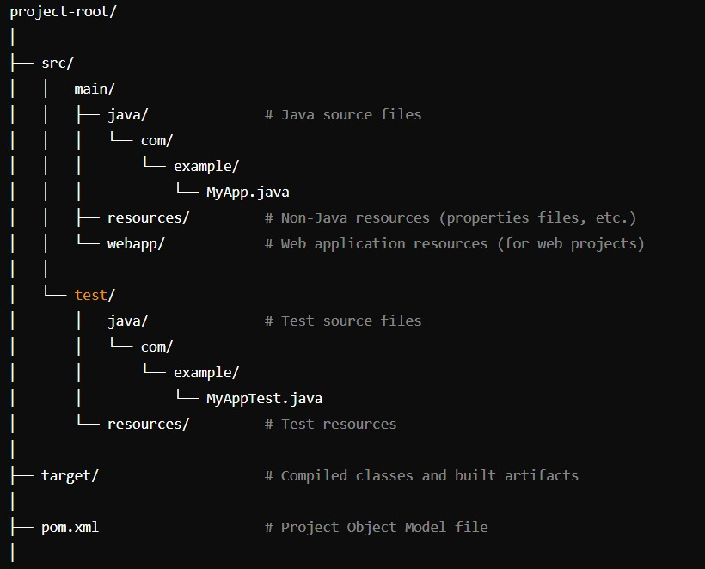

Creating a Maven Project

Creating a new Maven project is a straightforward process. The most common way is to use the Maven Archetype, which provides predefined project templates. Developers can generate a new Maven project from the command line using the following command:

Step 1:

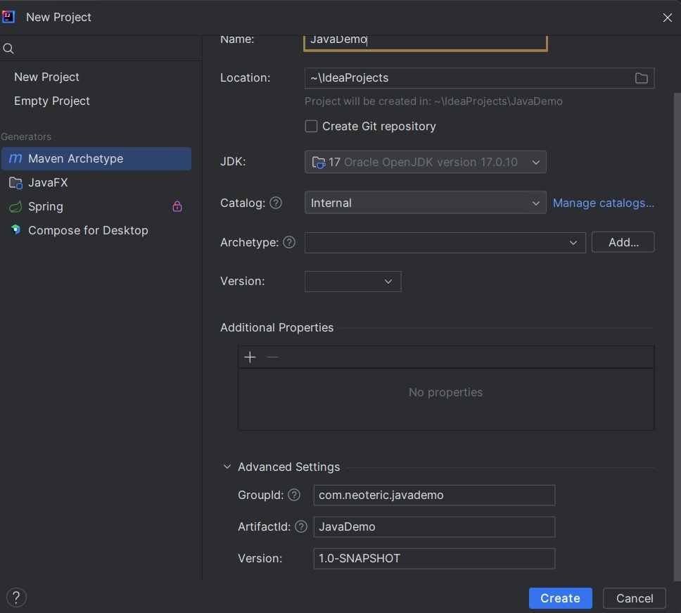

Step 2:

Managing Dependencies with Maven

One of Maven's most powerful features is its dependency management system. The pom.xml file allows developers to declare the external libraries and frameworks their project depends on. Maven then handles the process of downloading, managing, and resolving these dependencies, ensuring consistent and reproducible builds across different environments.

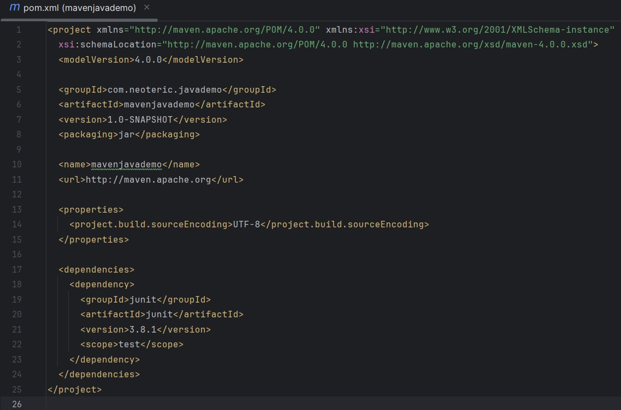

Step 3: Clean and Install

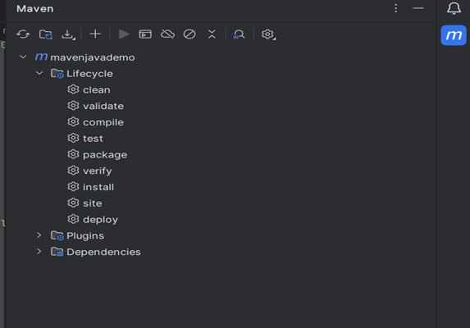

Step 4: After Install Building a jar

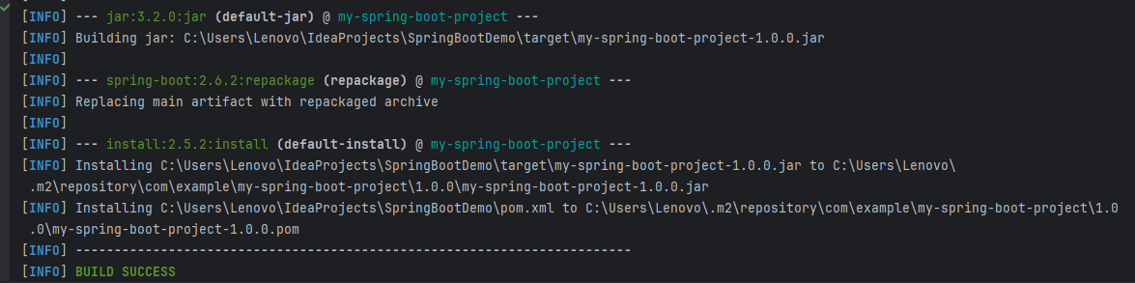

Step 5:m2 folder will be created click on folder

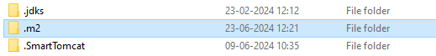

Step 6: Click on Local Repository



Step 7: Click on Group Id Com



Step 8: Click on Example Group Id

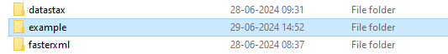

Step 9: Click on Arctifact Id

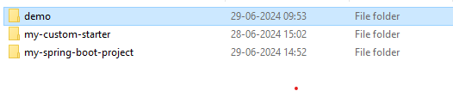

Step 10: Click on Version



Step 11: Jar file will be Created

